Freeing the door that won’t unlock

Perhaps it is a rare occurrence, but when it happens, it’s a pain. It is most likely to be the driver’s door, as this gets several thousand times more use than the passenger door. Having had this happen (at an inopportune time, of course), I resorted to getting in and out the passenger side to get home. Discussion with the Mazda agent on fixing it revealed that no, they hadn’t done one, and they would have to break into it. I decided to investigate if it could be done by myself.

The first step was to check the club website to see if anyone else had the problem, and possibly a fix. Sufficient owners have had the problem, but there didn’t appear to be instructive information on how to do it.

So here goes. My experience of unlocking the locked door. The actuator could be heard to click in and out so it was probable the electrical part was fine and it was purely a mechanical problem.

Step 1: Partial removal of the door trim was done as per the manual instructions. The door glass was in the down position at this point. The inner garnish was removed and the tweeter plug disconnected. The inner handle cover was removed. The switch panel was removed, but not disconnected at this stage. The two screws were removed. The door trim has a number of clips holding it in position. At the top there are two hook-type tabs. I started at the rear, by place a bent aluminium protector over the beltline moulding. The door trim was then carefully levered upward. There was enough flex in the plastic for the tab to be freed. The trim was then sitting on the inner metal edge of the door. I worked towards the front, easing the trim off the metal edge. The front tab was then freed in a similar manner.

Step 2: Starting from the top rear, the door trim clips were progressively released. After the first two it was found helpful to ease the door trim past the rear door catch. The same flat piece of aluminium facilitated this. A flat spatula (from the kitchen) helped to get at the remaining clips. It was not possible to fully remove the door trim as the large speaker at the front prevented this. However, releasing all the clips allowed the door trim to be tilted up enough to clear the seat base. Inevitably some of the clips broke, but they are an easily replaced item. To get working clearance for the next step a wooden block was used to hold the door trim inward.

Step 3: Removal of the door glass. The two plastic hole-covers in the centre were removed. The glass was raised 140mm above the exterior beltline moulding. The glass fixing screws were then in line with the holes. The screws were removed (10mm socket, short extension and ratchet) and the glass taken out by tilting it.

Step 4: A number of screws (7) on the inner panel were removed, starting from near the handle and working round the back and down to close to the speaker. A 10mm ratchet spanner was needed for these confined spaces. It was also necessary to remove a fastener near the handle, the nut on the top of the window mechanism, and a screw just above the actuator plug. I disconnected the plug to the actuator as the panel needed to be brought past the plug. The panel was eased inward and blocked in order to gain access to the space where the latch/lock actuator is situated.

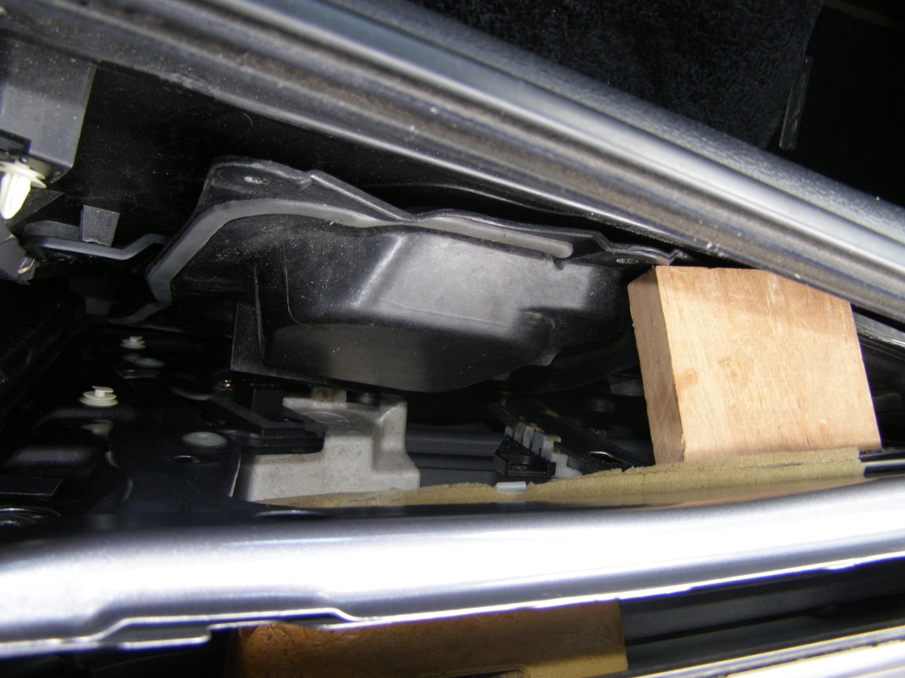
Door trim
Inner panel
Block
Access to latch/lock

Step 5: The latch/lock actuator has a plastic dust cover that needed to be removed in order to get at the mechanism. Having never seen the inside mechanism, I removed part of the dust cover. Though the cover is awkward to get at, a craft knife was all that was required to cut away part of the cover.

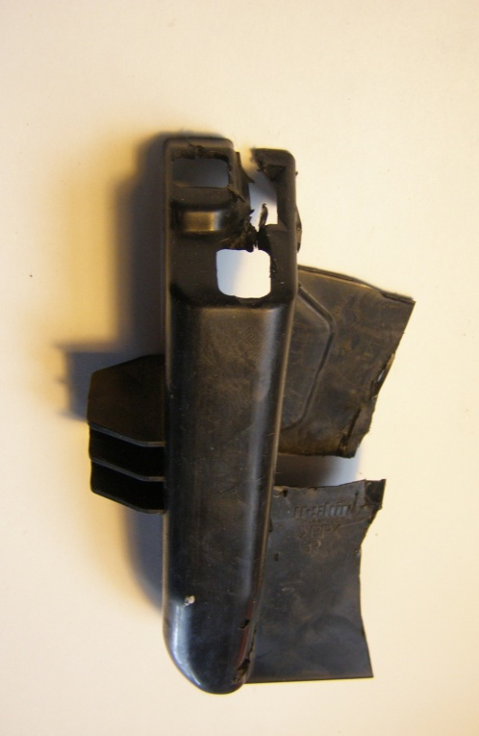 The part of the dust cover cut away.

A bit of fiddling with the metal parts and “click”, the door opened. The surprise was how little force was required

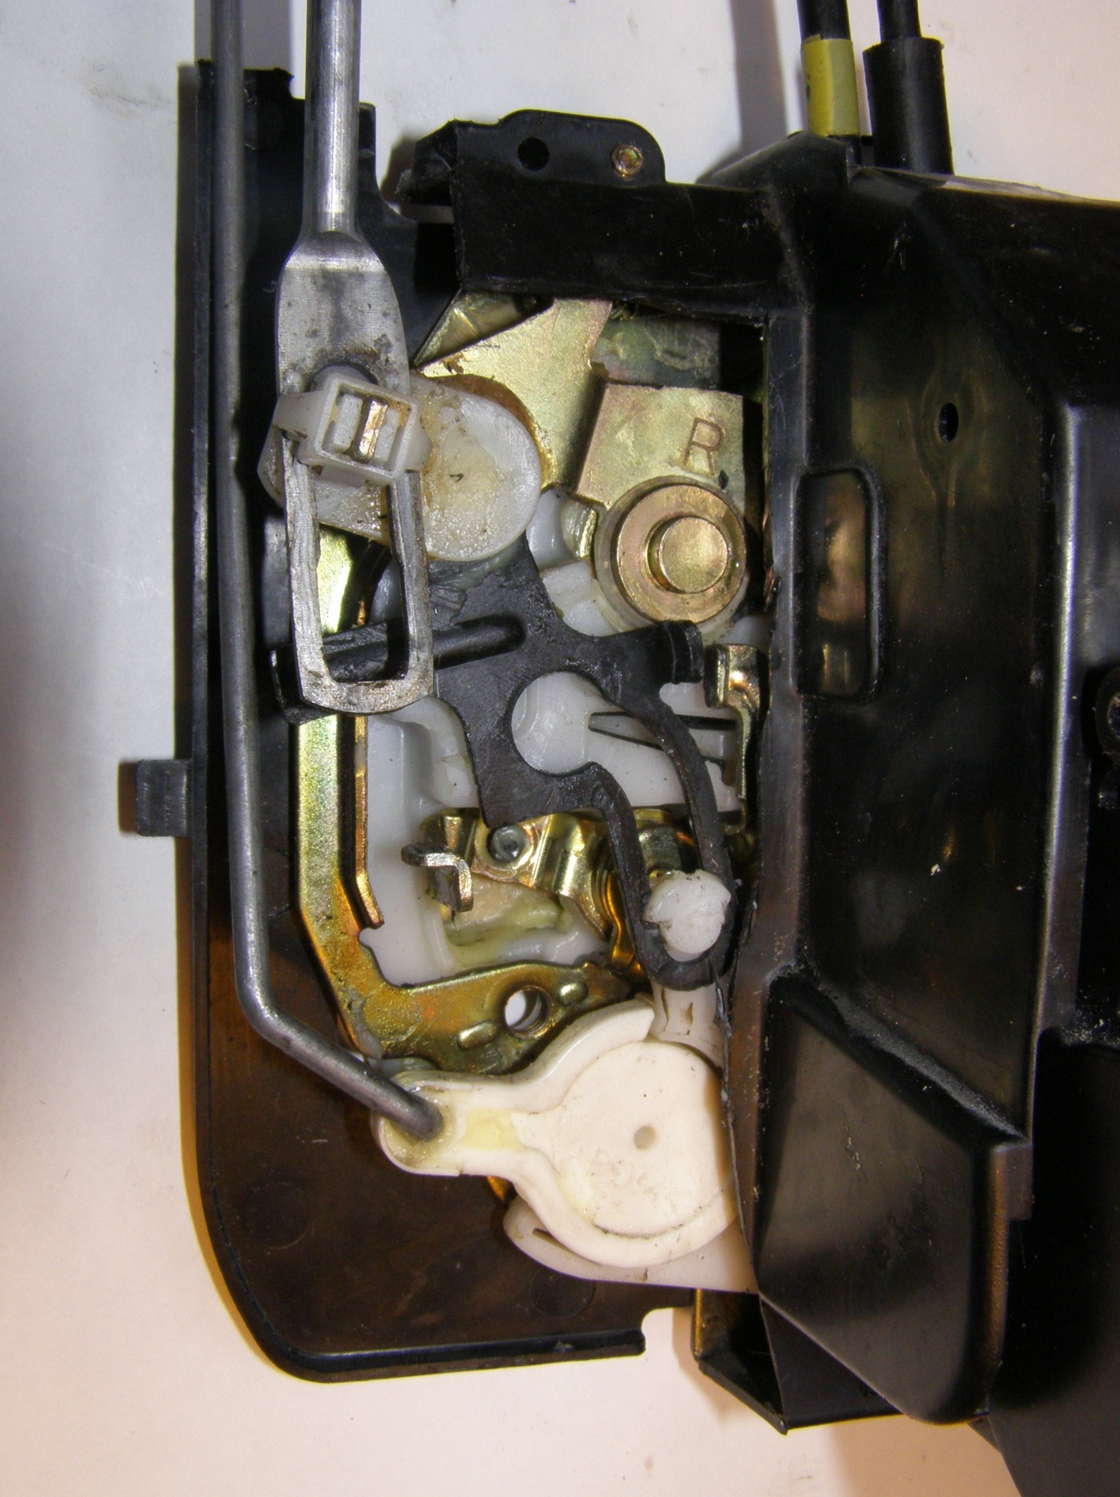

Here’s what the mechanism looks like after removal from the car.

Step 6: With the door open the door trim was fully removed and the latch/lock actuator three screws on the door jamb taken out. The control rods and cables were released at the exterior and interior handle ends. The latch/lock actuator was removed. It was not necessary to remove the inner panel.

In my case a small spring had broken, perhaps jamming the mechanism in the lock position.

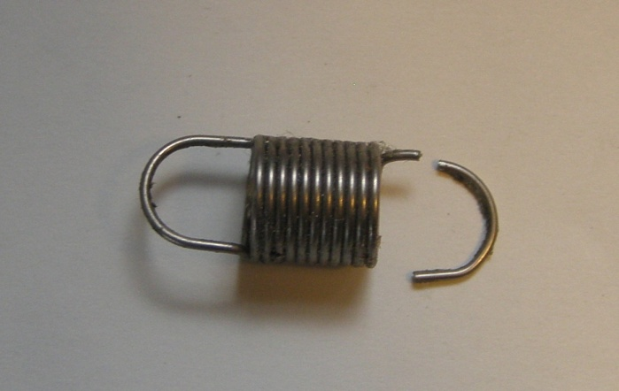 The offending spring

Fitting of another spring and reassembly was all that was required to get the door fully functioning again.

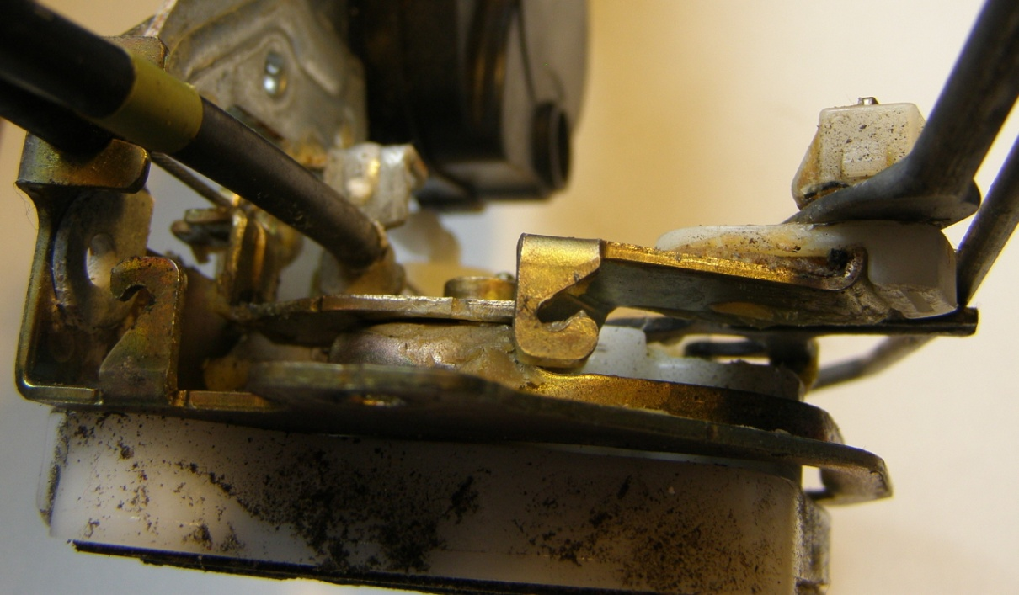

Where that spring was located at the top of the latch/lock.

